**Experiment 2.4**

**Name :- Yash Gupta Uid :- 20BCS5009**

**Course :- CSE Section :- 709-A**

**Subject :- Programming in Python Subject Code :- 20CSP-259**

# **Aim :-**

1. **Write a Python program to replace last value of tuples in a list**

**l = [(10, 20, 40), (40, 50, 60), (70, 80, 90)]**

**print([t[:-1] + (100,) for t in l])**

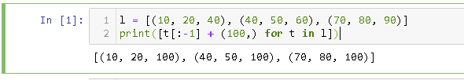

1. **Write a Python program to remove an empty tuple(s) from a list of tuples**

**def Remove(tuples):**

**tuples = [t for t in tuples if t]**

**return tuples**

**tuples = [(), (), ('a', 'b'), ('a', 'b', 'c'), ('d')]**

**print(Remove(tuples))**

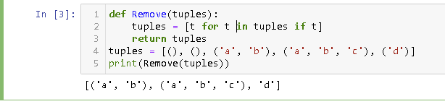

1. **Write a Python program calculate the product, multiplying all the numbers of a given tuple.**

**def mutiple_tuple(nums):**

**temp = list(nums)**

**product = 1**

**for x in temp:**

**product *= x**

**return product**

**nums = (4, 3, 2, 2, -1, 18)**

**print ("Original Tuple: ")**

**print(nums)**

**print("Product - multiplying all the numbers of the said tuple:",mutiple_tuple(nums))**

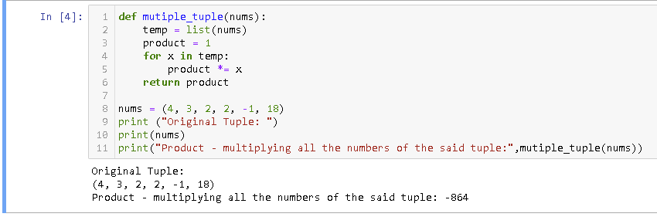

1. **Write a Python program to convert a tuple of string values to a tuple of integer values**

**def tuple_int_str(tuple_str):**

**result = tuple((int(x[0]), int(x[1])) for x in tuple_str)**

**return result**

**tuple_str = (('333', '33'), ('1416', '55'))**

**print("Original values:")**

**print(tuple_str)**

**print("\nNew values:")**

**print(tuple_int_str(tuple_str))**

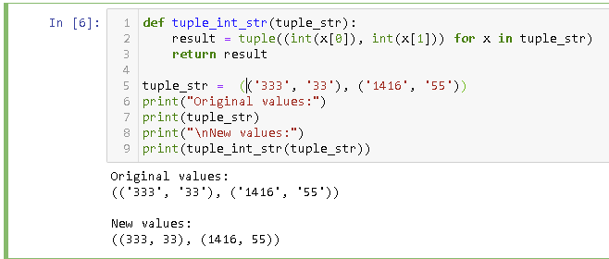

1. **Write a Python program to check if a specified element presents in a tuple of tuples**

**def check_in_tuples(colors, c):**

**result = any(c in tu for tu in colors)**

**return result**

**colors = (**

**('Red', 'White', 'Blue'),**

**('Green', 'Pink', 'Purple'),**

**('Orange', 'Yellow'),**

**)**

**print("Original list:",colors)**

**c1 = 'White'**

**print("\n",c1,"in tuple")**

**print(check_in_tuples(colors, c1))**

**c1 = 'Red'**

**print("\n",c1,"in tuple!")**

**print(check_in_tuples(colors, c1))**

**c1 = 'Black'**

**print("\n",c1,"in tuple!")**

**print(check_in_tuples(colors, c1))**

